**Google Maps API**

**Overview**

Google Maps API provides a comprehensive set of geospatial services that enable developers to integrate detailed and interactive maps, geolocation, and location-based services into their applications. It is widely used for its extensive coverage, accuracy, and robust features.

**Key Features**

1. Maps: Interactive maps that can be embedded into websites and mobile applications, with customizable map styles and layers.
2. Geocoding and Reverse Geocoding: Convert addresses to geographic coordinates and vice versa.
3. Directions and Routing: Calculate directions and routes for driving, walking, biking, and public transit.
4. Places: Access detailed information about places, including names, addresses, photos, reviews, and ratings.
5. Distance Matrix: Calculate travel distance and time between multiple points.
6. Street View: Panoramic street-level imagery.
7. Geolocation: Determine the location of devices based on Wi-Fi and cell tower data.
8. Time Zone: Retrieve time zone information for a specific location.
9. Elevation: Get elevation data for specific locations or paths.

**Pricing**

Pricing varies by service, e.g., $7 per 1,000 map loads, $5 per 1,000 geocoding requests, $5 per 1,000 directions requests, etc.

https://mapsplatform.google.com/pricing/

**Pros and Cons**

**- Pros**

1. High Accuracy: Reliable and accurate geospatial data.
2. Extensive Coverage: Global coverage with detailed information.
3. Rich Features: Comprehensive set of features for various geospatial needs.
4. Scalability: Scalable infrastructure to handle high volumes of requests.
5. Regular Updates: Continuously updated data and features.

**- Cons**

1. Cost: Can become expensive for high-volume applications.
2. Complexity: A wide range of features and options can be complex to navigate.
3. Usage Limits: Free tier may not be sufficient for large-scale applications, leading to additional costs.

**Official Documentation URL**

https://developers.google.com/maps/apis-by-platform

**OpenStreetMap API(open source)**

**Overview**

OpenStreetMap (OSM) API provides access to the vast OpenStreetMap database, which is a collaborative project that creates a free, editable map of the world. The API allows developers to query and retrieve map data, including geographical features, roads, buildings, and other elements.

**Key Features**

1. Data Access: Access to detailed geographical data including roads, buildings, parks, and more.
2. Editing: Capabilities to add, modify, and delete map data.
3. Overpass API: A powerful API for querying OSM data with complex filters.
4. Nominatim: Geocoding service to convert addresses into geographic coordinates and vice versa.
5. OSRM (Open Source Routing Machine): A routing engine that provides route calculations based on OSM data.
6. Custom Maps: Ability to render custom maps using OSM data.

**Pricing (if applicable)**

Free

**Pros and Cons**

**- Pros**

1. Free and Open Source: No cost for accessing and using the data.
2. Community-driven: Constantly updated and improved by a global community of contributors.
3. Customizability: Highly customizable for specific use cases.
4. Global Coverage: Extensive and detailed global map coverage.

**- Cons**

1. Usage Limits: Public API has usage limits and may not be suitable for high-volume applications without setting up your own infrastructure.
2. Complex Setup: May require significant setup and maintenance for self-hosting solutions.
3. Data Quality: Data quality can vary by region depending on the level of community involvement.

**Official Documentation URL**

https://www.openstreetmap.org/about/api/

**Azure Maps API(from Bing Maps API)**

**Overview**

Azure Maps is a collection of geospatial services and SDKs that use fresh mapping data to provide geographic context to web and mobile applications. Azure Maps provides:

* REST APIs to render vector and raster maps in multiple styles and satellite imagery.
* Search services to locate addresses, places, and points of interest around the world.
* Various routing options; such as point-to-point, multipoint, multipoint optimization, isochrone, electric vehicle, commercial vehicle, traffic influenced, and matrix routing.
* Traffic flow view and incidents view, for applications that require real-time traffic information.
* Time zone and Geolocation services.
* Geofencing service and mapping data storage, with location information hosted in Azure.
* Location intelligence through geospatial analytics.

Additionally, Azure Maps services are available through the Web SDK. These tools help developers quickly develop and scale solutions that integrate location information into Azure solutions.

**Key Features**

**（found at: https://learn.microsoft.com/en-us/azure/azure-maps/about-azure-maps）**

1. Map Rendering: Interactive and customizable maps with various layers (e.g., traffic, weather).
2. Geocoding and Reverse Geocoding: Convert addresses to geographic coordinates and vice versa.
3. Routing: Calculate optimal routes for driving, walking, and public transit, including multi-stop routes.
4. Traffic Information: Real-time traffic data and incident information.
5. Weather Services: Access current weather conditions, forecasts, and severe weather alerts.
6. Spatial Operations: Perform spatial analysis like buffer, closest point, and within polygon queries.
7. Time Zone API: Determine time zones and convert times for different locations.
8. Geofencing: Create and manage geofences for location-based triggers and alerts.

**Pros and Cons**

**- Pros**

1. Comprehensive Services: Wide range of geospatial services covering various use cases.
2. Integration with Azure: Seamless integration with other Azure services and products.
3. High-quality Data: Access to reliable and accurate geospatial data.
4. Scalability: Designed to scale with the needs of large applications.

**- Cons**

1. Cost: Pay-as-you-go pricing can become expensive for high-volume applications.
2. Complexity: May require significant effort to set up and integrate with existing systems.
3. Learning Curve: Steep learning curve for developers new to Azure and its ecosystem.

**Official Documentation URL**

https://learn.microsoft.com/en-us/azure/azure-maps/

**Yelp API**

**Overview**

The Yelp API provides access to Yelp’s database of over 150 million businesses across various categories such as restaurants, shopping, nightlife, and more. It allows developers to retrieve detailed information about businesses, including reviews, ratings, photos, and other relevant data.

**Key Features**

1. Business Search: Search for businesses by location, term, category, price level, and more.
2. Business Details: Retrieve comprehensive information about a specific business, including address, phone number, hours, photos, and review highlights.
3. Reviews: Access reviews for a specific business, including the review text, rating, and user information.
4. Autocomplete: Provides autocomplete suggestions for search queries based on user input.
5. Event Search: Search for events by location, date, category, and other filters.
6. Transaction Search: Filter businesses based on whether they support certain transactions like delivery, pickup, or reservations.

**Pricing**

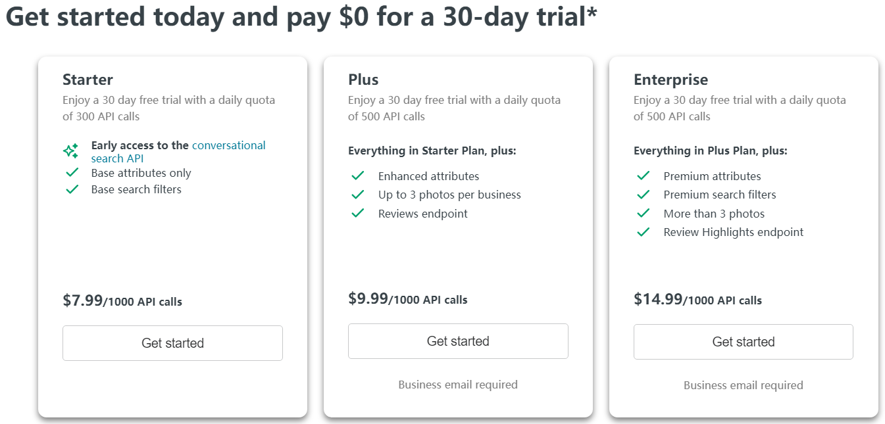

https://docs.developer.yelp.com/page/start-your-free-trial

**Pros and Cons**

**- Pros**

1. Comprehensive Data: Access to detailed information about millions of businesses.
2. User Reviews: Get insights from user reviews and ratings.
3. Rich Filters: Multiple filtering options for precise searches.
4. Geographical Coverage: Wide coverage in many countries.

- **Cons**

1. Usage Limits: Free tier has request limits which might be restrictive for high-volume applications.
2. Rate Limiting: Potential rate limiting which can affect the speed of data retrieval.
3. Complexity: The API can be complex to use for beginners due to the variety of endpoints and parameters.

**Official Documentation URL**

[/businesses/search](https://docs.developer.yelp.com/reference/v3_business_search)

FROM: https://docs.developer.yelp.com/docs/fusion-intro

**Mapbox API**

**Overview**

Mapbox API provides a suite of location-based services and tools for developers to integrate custom maps, geolocation, and spatial analysis into their applications. It leverages open data from sources like OpenStreetMap and provides advanced customization and styling options.

**Key Features**

1. Customizable Maps: Create and style interactive maps with custom layers, colors, and data.
2. Geocoding and Reverse Geocoding: Convert addresses to geographic coordinates and vice versa.
3. Directions and Routing: Calculate directions and routes for driving, walking, biking, and public transit.
4. Mapbox Studio: A powerful tool for designing and customizing maps.
5. Navigation SDK: Tools for building navigation experiences in mobile applications.
6. Static Maps: Generate static map images for use in websites and applications.
7. Search: Search for places, addresses, and points of interest.
8. Tilesets: Access to high-quality, customizable map tiles.
9. Geospatial Analysis: Tools for spatial analysis and visualization.

**Pricing**

https://www.mapbox.com/pricing

**Pros and Cons**

**- Pros**

1. Customization: Highly customizable maps and visualizations.
2. User-Friendly Tools: Mapbox Studio provides an intuitive interface for designing maps.
3. Scalability: Scalable infrastructure suitable for high-volume applications.
4. Open Data: Leverages open data sources like OpenStreetMap, providing transparency and community-driven updates.

**- Cons**

1. Cost: Can become expensive for high-volume usage beyond the free tier.
2. Complexity: Advanced customization options can be complex for beginners.
3. Data Variability: Data quality and coverage can vary depending on the region and source data.

**Official Documentation URL**

https://docs.mapbox.com/api/overview/

**Other location APIs:**

Here Maps API

TomTom API